**PROPOSAL**

**DEVELOPMENT, IMPLEMENTATION AND MAINTANANCE OF MUNICIPAL MONITORING AND SUPPORT IT SYSTEMS FOR A PERIOD OF 36 MONTHS**

**FOR**

**DEPARTMENT OF CO-OPERATIVE GOVERNANCE & TRADITIONAL AFFAIRS**

**BID NUMBER: CGT/091/22/MP**

**CONTENT**

1. **Executive Summary…………………………………………………… 4**
   1. **Company background ……………………………………. 4**
   2. **Our Services …………………………………………………. 4**
   3. **Credentials …………………………………………………… 4**
   4. **Company organogram ……………………………………. 7**
2. **Project Summary ……………………………………………………… 7**
   1. **Project Description/Statement …………………………… 7**
   2. **Project Aim and Objectives ………………………………. 7**
3. **Stakeholders ……………………………………………………………. 8**
4. **Project Scope …………………………………………………………… 8**
5. **Proposed System requirements ……………………………………. 22**
   1. **Platforms Supported ……………………………………….. 22**
   2. **Web Server Hardware ……………………………………… 23**
   3. **Deliverables ………………………………………………….. 23**
6. **Project implementation plan ……………………………………….. 25**
7. **Resources ………………………………………………………………. 29**
8. **Pricing schedule ……………………………………………………… 30**
   1. **Summarised Resources Rates for the whole project… 30**
   2. **Cost analysis ……………………………………………….. 31**
   3. **Monthly service level agreement ………………………. 31**

**Statement of Confidentiality & Non-Disclosure**

This document contains proprietary and confidential information. All data submitted to the Department of Co-operative Governance & Traditional Affairs is provided in reliance upon its consent not to use or disclose any information contained herein except in the context of its business dealings with Forek ICT Services. The recipient of this document agrees to inform present and future employees of the Department of Co-operative Governance & Traditional Affairs who view or have access to its content of its confidential nature.

The recipient agrees to instruct each employee that they must not disclose any information concerning this document to others except to the extent that such matter is generally known to, and are available for use by, the public. The recipient also agrees not to duplicate or distribute or permit others to duplicate or distribute any material contained herein without Forek ICT Services express written consent.

Forek ICT Services retains all title, ownership and intellectual property rights to the material and trademarks contained herein, including all supporting documentation, files, marketing material, and multimedia.

BY ACCEPTANCE OF THIS DOCUMENT, THE RECIPIENT AGREES TO BE BOUND BY THE AFOREMENTIONED STATEMENT

1. **Executive Summary**
   1. **Company background**

Forek Institute of Technology is an ICT Service provider that was established in 2007, operating at 9 Piet Retief Street, Nelspruit. It was previously operating as Forek IT Services CC, but later registered as Forek Institute of Technology (PTY) Ltd in 2012.

**FOREK IT SERVICES** is a dynamic, black owned information technology company, which was founded in 2007 by youth but matured technologists. The company focuses on **software development, web development, network solution, IT Strategies and IT Security System.** The company was founded by **Ekson Fortune Sibiya** who obtained a **Bsc degree in computer science**. He worked for **AFRISAT** as a Junior Software and Web developer for the period of one year where he developed a website for Mpumalanga Parks Board before it merged with MTA and he was also part of the development of Procurement System for Mpumalanga Parks Board. He then established the company called **Abamnyama Technologies** where he was 50% share holder. **Abamnyama Technologies** developed a school management system that is managing the school records and the system is installed in 150 schools situated in Mpumalanga Province, Ehlanzeni region. In understanding the level of growth and participation in the frame of economy taking an advantage of young entrepreneurship, **Ekson Fortune Sibiya** established **Forek IT Services**.

Based on our experiences, the following key factors are important for ensuring a successful business engagement:

* Ensure proper Project Requirement Analysis
* Scheduled project delivery and release.
* Adhering to Operation Level Agreement (OLA)
* Value-add to client’s business needs by fine-tuning existing strategies.
* Ethical and sincere approach towards work.
* Our object oriented commitment, thereby earning trust and respect. Commitment to client’s success.
* Continuous and steady improvement with a robust Business Continuity Plan.
* Commitment to business excellence, innovation, quality and speed with proper focus on results.
* Proper risk managements controls.
* Due maintenance/support of project after delivery
* Ensuring high Customer Satisfaction metrics

The company has a vast experience in working with Municipalities, Government Department, Parastatals, NGOs and Private Business in developing Websites, Networking Infrastructure Setup, Mobile, Desktop and Web-based systems. We also have extensive experience in the configuration and setup of IP Cameras, CCTV installation and many other peripheral devices.

* 1. **Below is a list of Software Programmes that we have developed inhouse.** 
     1. **College Management System**
     2. **Tribal Authority System**
     3. **Project Profiling**
  2. **Our Services**
     1. Total ICT Outsource
     2. Software Development and Maintenance
     3. Website Development and Maintenance
     4. System Integration
     5. Networking
     6. Business Information Systems
     7. Developing Solutions for different businesses
     8. CCTV Installation and Maintenance
        1. Disaster Management
     9. ICT Governance
     10. Server Administration
     11. IT Auditing
  3. **Credentials**

Forek Institute of Technology has worked with various Government Departments and Municipalities. Below is a list of projects we have successfully implemented.

|  |  |  |  |
| --- | --- | --- | --- |
| CLIENT NAME | SERVICE DETAILS | CONTACT | CONTRACT VALUE |
| 1. Department of Community Safety, Security and Liaison | Development of the Complaints Management, and Tracking System | Contact: Mr M Vuma  Tel: 013 755 4384 | R 2,100,000.00 |
| 1. Mbombela Local Municipality partnership with BCX | Total Outsource ICT Support focusing on: | Contact: Mr Mahesh  Tel: 013 759 9111 | R 8,964,000.00 |
| 1. Victor Khanye Local Municipality | Total Outsource ICT Support focusing on: | Contact: John Thwala  Tel: 013 665 6000 | R 23,112,000.00 |
| 1. Mbombela Local Municipality. | Development of dynamic website and Intranet. | Contact: Mr. Joseph Ngala  TEL: 013-759 2378 | R 218,000.00 |
| 1. Department of Human Settlement | Development and Implementation of Profiling Management System, the system is responsible for profiling of job applicants. | Contact: Mr. Oriel Singwane  TEL: 013-766 6855 | R 360,000,00 |
| 1. Department of Economic Development, Environment and Tourism | Development and Implementation of Project Profiling System, the system is responsible for capturing the data for all provincial projects. | Contact: Innocentia Sithole  TEL: 013 766 0000 | R 60,000.00 |
| 1. Department of Culture, Sport and Recreation | Design and Installation of security system, the system for anti-theft book devices that is responsible for monitoring of in and out books in the library. The system is installed in four libraries. | Contact: Mr Musa Sambo  TEL: 013-766 7024 | R 500,000.0 |
| 1. Victor Khanye Local Municipality | Development of the Municipality Website | Contact: John Thwala  Tel: 013 665 6000 | R 180,000.00 |
| 1. Victor Khanye Local Municipality | Forek Help Desk Management System | Contact: John Thwala  Tel: 013 665 6000 | R 240,000.00 |
| 1. Department of public Works, roads and transport | Development of the Departmental Website | Contact: Mr E Sigudla  Tel: 013 766 6696 | R 118,000.00 |
| 1. Mbombela Municipality | Development of Mbombela FIFA World cup 2010, website | Contact: Mr Mahesh  Tel: 013 759 9111 | R 180,000.00 |
| 1. Mbombela Municipality | Website Development and Maintenance | Contact: Mr Mahesh  Tel: 013 759 9111 | R 240,000.00 |
| 1. Nkomazi Local Municipality | Development of Website and Intranet | Contact: Mr Jerry Khoza  Tel: 013 790 0245 | R 120,000.00 |
| 1. Mpumalanga Regional Training Trust | Development of Website and maintenance | Contact: Ms Zanele  Tel: 013 656 0875 | R 160,000.00 |

* 1. **Company Organogram**

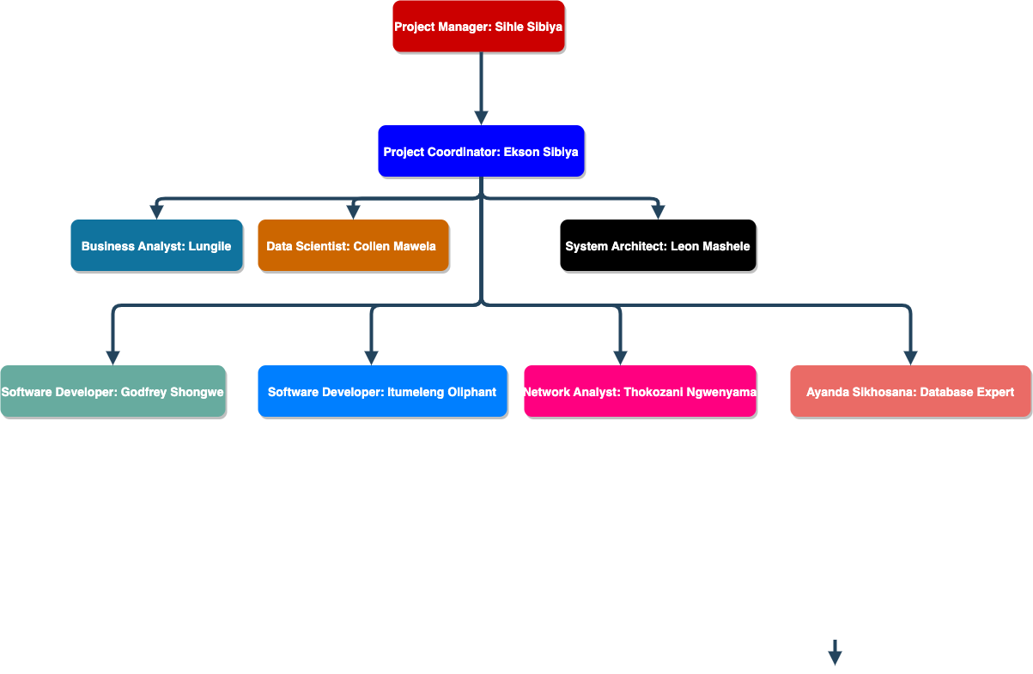

1. **Project Summary**
   1. **Project Description/Statement**

Forek Institute of Technology fully understands that the Mpumalanga Co-operative Governance seek to address the following shortcomings in the existing reporting system:

* + 1. Manual method of documenting municipal reports not effective and efficient
    2. Non-compliance to legislation
    3. Lack of database applications
    4. Contract management not integrated in municipal reporting
    5. Tracking and tracing of project requests by clients and a computerized process that would expedite the assessment of such project requests
  1. **Project Aim and Objectives**
     1. **Aim**
* The main aim of the proposal is to design a web-based system with a dashboard that will allow the department to monitor and assess the performance of Municipalities and allow for the support to municipalities as provided for in section 105 of the local government act.
  + 1. **Objectives**
* Is to develop a web-based application to capture, store and retrieve municipal information efficiently and without any hassles.
* Ensuring standardization in terms of project identification, coordination, liaison, data collection, verification, collation, analysis, dissemination, monitoring, and evaluation as well as reporting

1. **Stakeholders**

|  |  |
| --- | --- |
| Stakeholder | Role(s) |
| Forek Institute of Technology | ICT Service Provider (Bidder) |
| Mpumalanga Department of Co-operative & Traditional Affairs | Client (Bid Issuer) |
| Local Municipalities in Mpumalanga | End Users |

1. **Project Scope**

Forek institute of technology clearly understand that the Department of Co-operative Governance & traditional Affairs have identified gaps in their current system hence, a Web based electronic system is needed to reduce, if not eliminate the non-compliance with applicable policies and legislation in that it would be based on an electronic template that would compel the user insert certain required information to moving to the next step in capturing information.

However, to make sure that all the gaps identified in the problem statement are addressed, Forek institute of Technology proposes a multi-faceted web-based system with modules outlined below to make sure that COGTA achieves their strategic goals.

**Project Profiling Management System (Module)**

1. **System Overview**

Based on the problem-statement as well as the needs-analysis conducted – we found it necessary to incorporate a Profiling Management Module. This module will cater for the following:

* The monitoring of various municipal projects
* Reporting on Municipal Infrastructure Grant (MIG)
* Ensuring the development of Key Performance Areas
* Conducting regular performance reviews
* Project reporting
* Implementation of performance management
* Project Communication etc

1. **Description**

In essence the Project management module will be used to plan, organize, and allocate resources for managing municipal projects. It will help the departments keep track of the project’s progress while clearly defining tasks and responsibilities. It lets project managers control costs and time and allows smooth collaboration between stakeholders.

To deliver projects on time, teams must keep everything organized particularly when there are multiple ongoing projects. This module will provide an overview of all the projects, helps prioritize tasks, and keeps everyone on the same page.

1. 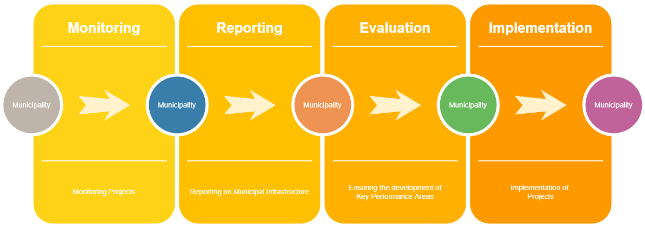**Diagrammatic Sketch**

**Public Participation Management System**

1. **System Overview**

Herein this module will ensure that the following features are catered for. These includes – but are not limited to the following:

* The reporting of monthly activities within various wards.
* The reporting of community meeting participation.
* Monthly instalments of meetings, operational plans.
* Regular service reporting tools.

1. **Description**

Beyond just the overview of this module – this module will also ensure that all systems are in place for the coordination of public participation activities in various wards.

1. **Use-Case Diagram**

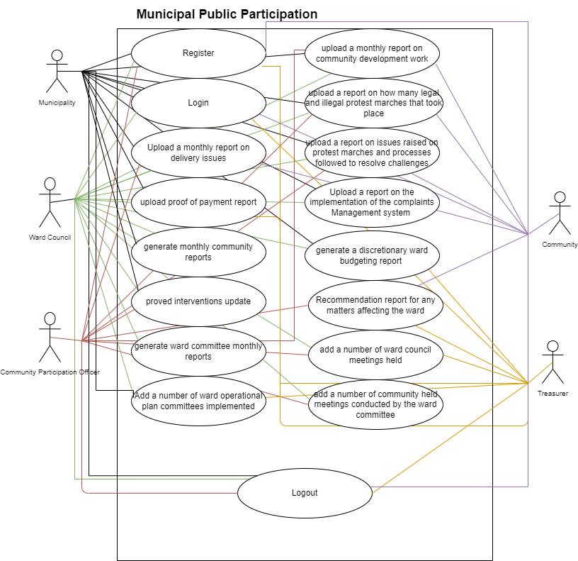

**Contract Management System**

1. **System Overview**

This module will enable department and municipalities to:

* Make contractual amendments
* Make contractual negotiations
* Update existing contracts
* As well as to track and monitor existing contracts assigned to suppliers, vendors and whether they deliver according to their contractual obligations.
* Contract Renewing
* Soliciting Contract Approvals

1. **Description**

Every transaction undertaken by an organisation involves a contract whether explicitly agreed in writing, or implicitly implied through actions. Properly managed contracts can ensure that services are delivered within specification and at the agreed cost.

1. **Diagrammatic Sketch**

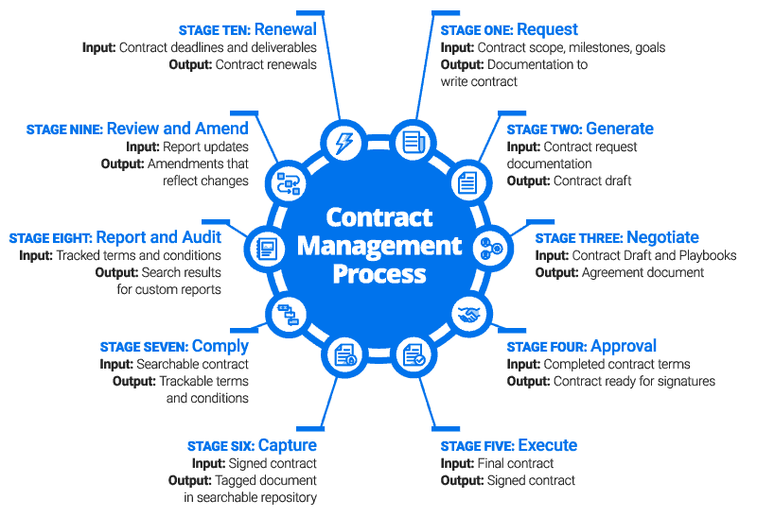

**Document Management System**

1. **System Overview**

This module of the system will extend functionalities of organizing, storing (archiving), manage and track electronic documents.

1. **Description**

Basically, this module will help the municipality to capture, track and store electronic documents such as PDFs, word processing files and digital images of paper-based content.

Document management can save you time and money. It provides document security, access control, centralized storage, audit trails and streamlined search and retrieval.

1. **Diagrammatic Sketch**

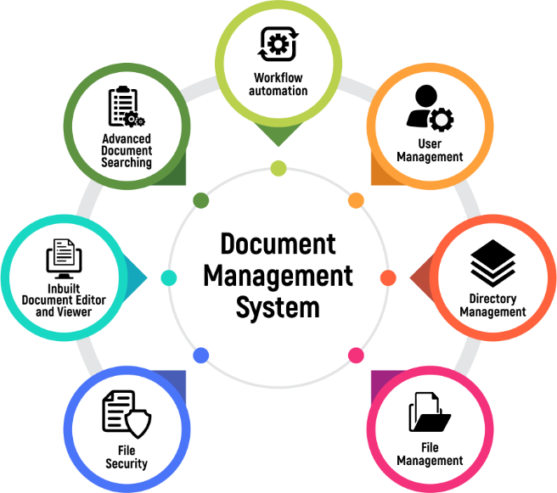

**Financial Management System**

1. **System Overview**

At the core of this module is to provide a module capable of managing municipal assets, income and expenses. The FMS performs various functions: reducing accounting errors, maintaining audit trails and ensuring compliance with applicable accounting standards.

1. **Description**

This financial module will help in organizing municipalities oversee and govern its income, expenses, and assets with the objectives of maximizing profits and ensuring sustainability. This financial management module will improve short- and long-term municipal performance by streamlining invoicing and billing. Collection, eliminating accounting errors, minimizing record-keeping redundancy, ensuring compliance with tax and accounting regulations, helping municipal personnel to quantify budget planning, and offering flexibility and expandability to accommodate change and growth.

1. **Use-Case Diagram**

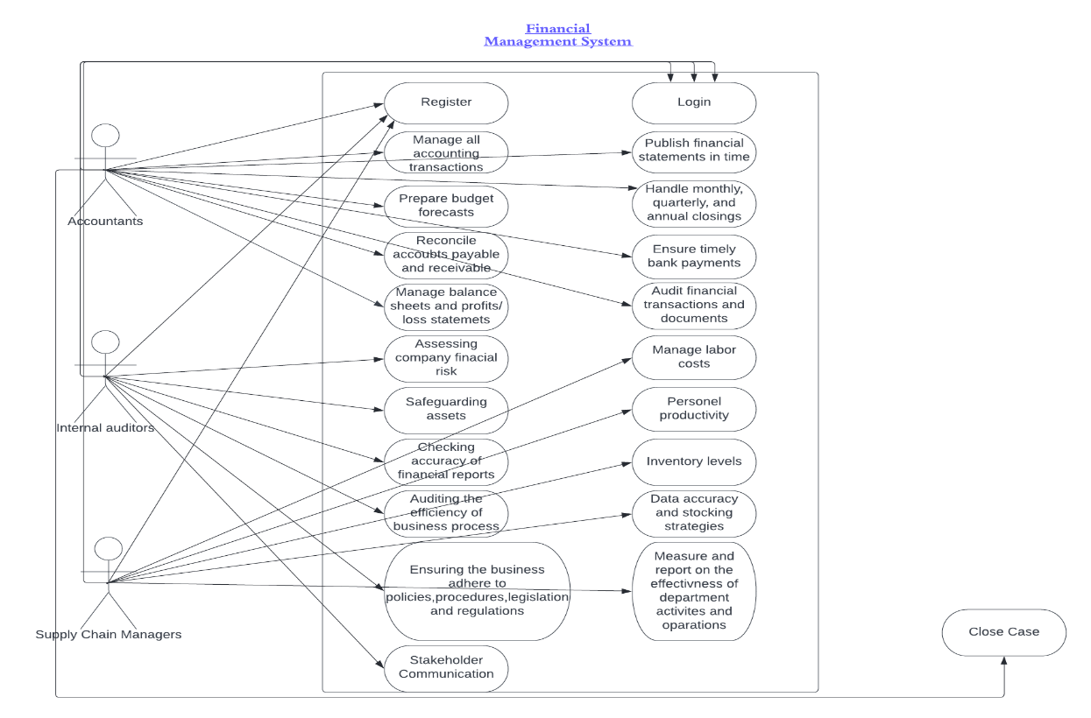

**Performance Management System**

1. **System Overview**

This module will enable municipalities to achieve and set Performance Targets. These entails the milestones the department sets for itself. The targets will usually be expressed in terms of quantity or time.

1. **Description**

This module will help the department to continuously track and monitor municipal performance. Not only will this module ensure that

Municipalities are working effectively toward aligned organizational goals, but they help in terms of optimal performance on a transparent basis.

1. 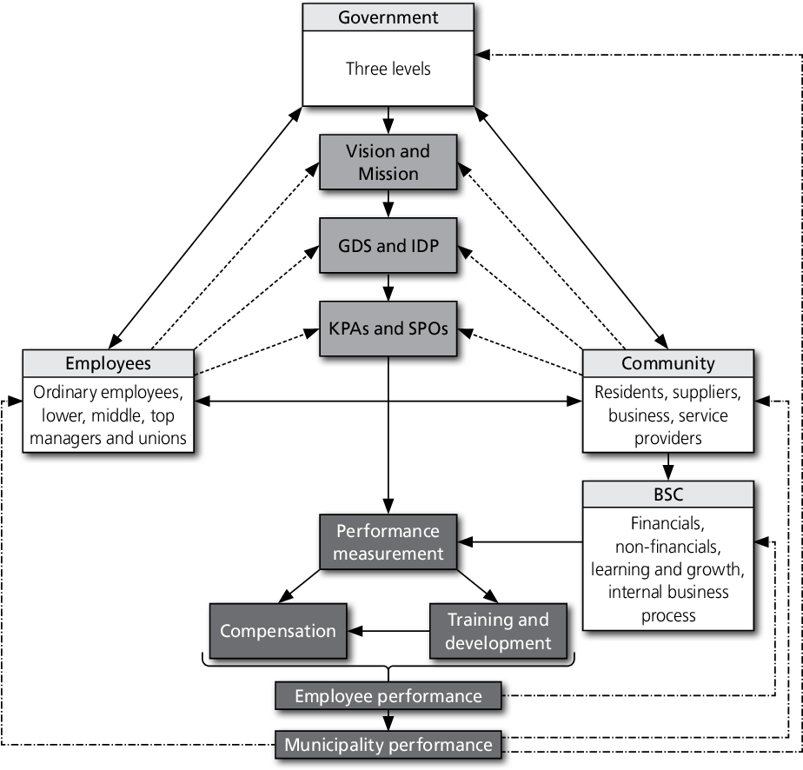**Diagrammatic Sketch**

**Asset Management System**

1. **System Overview**

The goal of this module is to achieve the required level of service in the most cost-effective manner, which is achieved through the management of municipal’s asset’s life cycle.

1. **Description**

Effective asset management in municipalities will ensure the following are achieved:

* Maximize the service potential of existing assets by ensuring that they are appropriately used, maintained, safeguarded and that risks are mitigated.
* Optimise the life-cycle cost of owning and using these assets by seeking cost-effective options throughout an asset’s life-cycle
* Reduce the demand for new assets through the optimal use of existing assets and management of demand through the use of non-asset service delivery option
* Establish clear lines of accountability and responsibility for performance.

1. 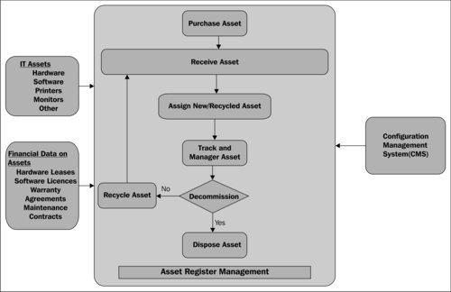**Use-Case Diagram**

**Service Delivery Management System**

1. **System Overview**

In order to achieve optimal service delivery, each municipal government should choose a delivery system that is best suited to the type of municipality concerned and after taking into account all the special needs of the local communities.

1. **Description**

This section of the system will deal primarily with catering for municipal service delivery. The gist of this module will be to manage how services are rendered to communities and how to optimize such operations.

1. **UML Design**

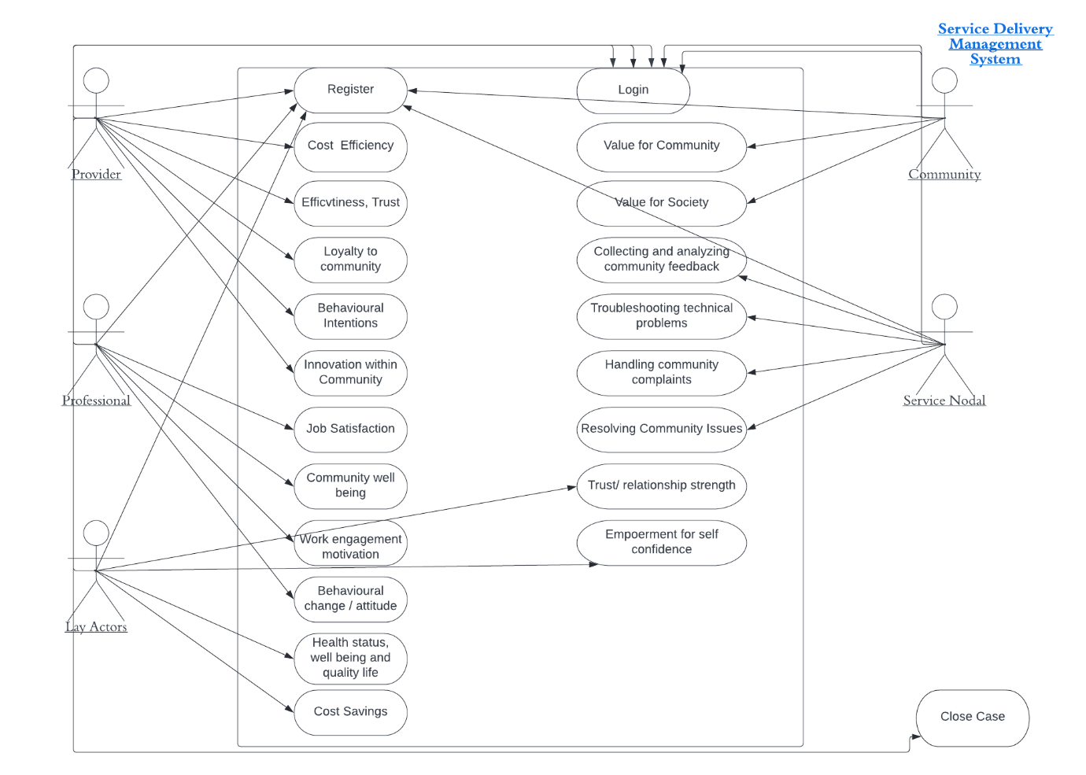

**Tribal Management System**

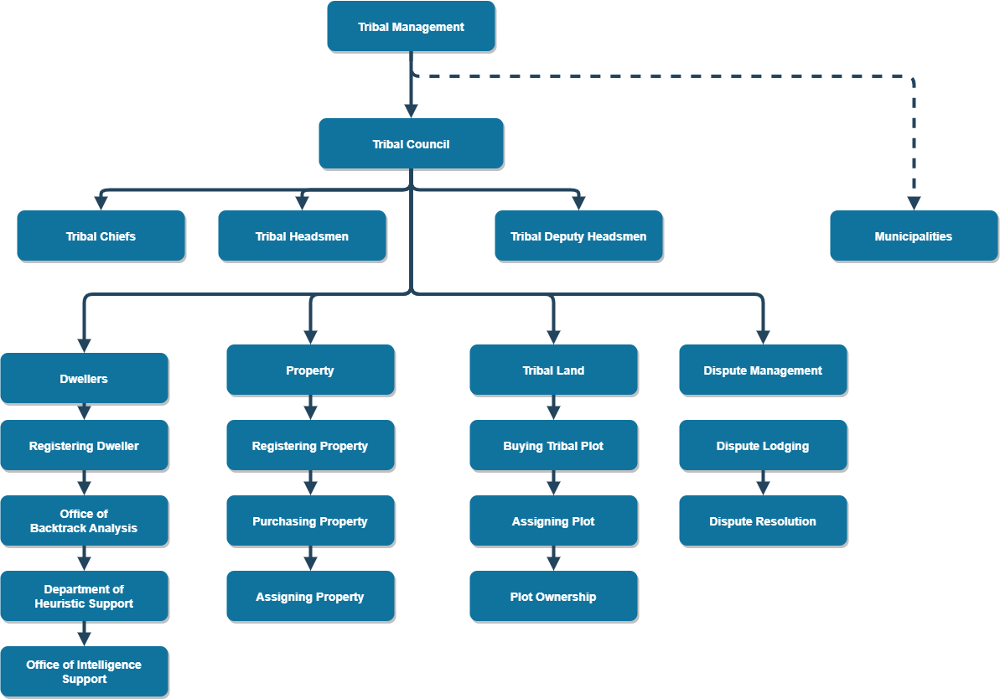

**ICT Governance Management System**

1. **System Overview**

The governance in Information & Communication exists to inform and align decision making for ICT planning, policy and operations in order to meet municipal’s objectives, ascertain those risks are managed appropriately and verify that resources are being used responsibly and strategically.

1. **Description**

This module is aimed at improving the overall management of IT in municipalities and deriving improved value from investment in information and technology.

This module is aimed at improving the overall management of IT and deriving improved value from investment in information and technology.

1. **Diagrammatic Sketch**

Executive Authority

Mayor/Municipal

Municipal Manager

Municipal Manager/HODs/As signed councillors

Municipal ICT Steering Committee

Municipal Risk Committee

ICT Audit Committee

Process Level

IT Manager/IT Department

Tactical Management

**Municipal Ward Management System**

1. **System Overview**

This module will facilitate the process of managing various wards.

1. **Description**

Various reports pertaining to the management of ward’s finances, community meetings and their outcomes, as well as having a ward repository that details all its operations.

1. **Use-Case Diagram**

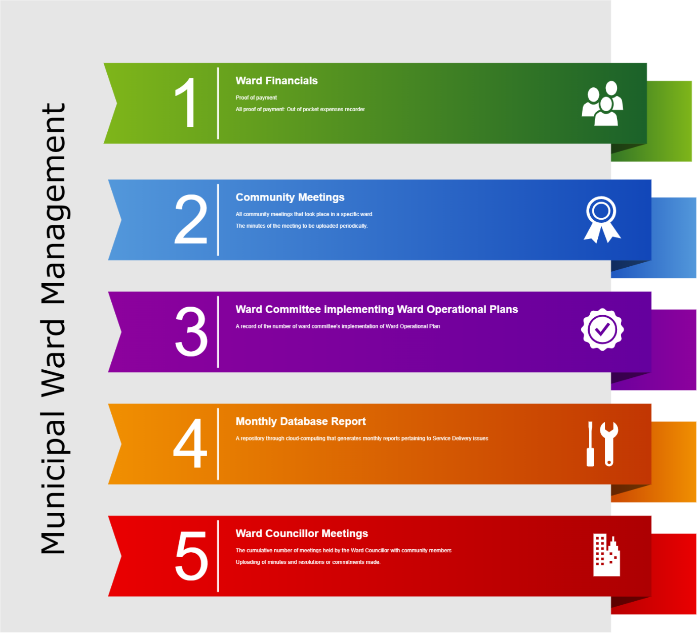

**Disaster Management System**

1. **System Overview**

This module will deal with functions that encompasses a range of disaster related activities, including preparedness, planning, procurement, warehousing etc

1. **Description**

The core of this module will be centred around the reporting of occurrences of natural disasters, uploading of Disaster related reports etc.

1. **Use-Case Diagram**

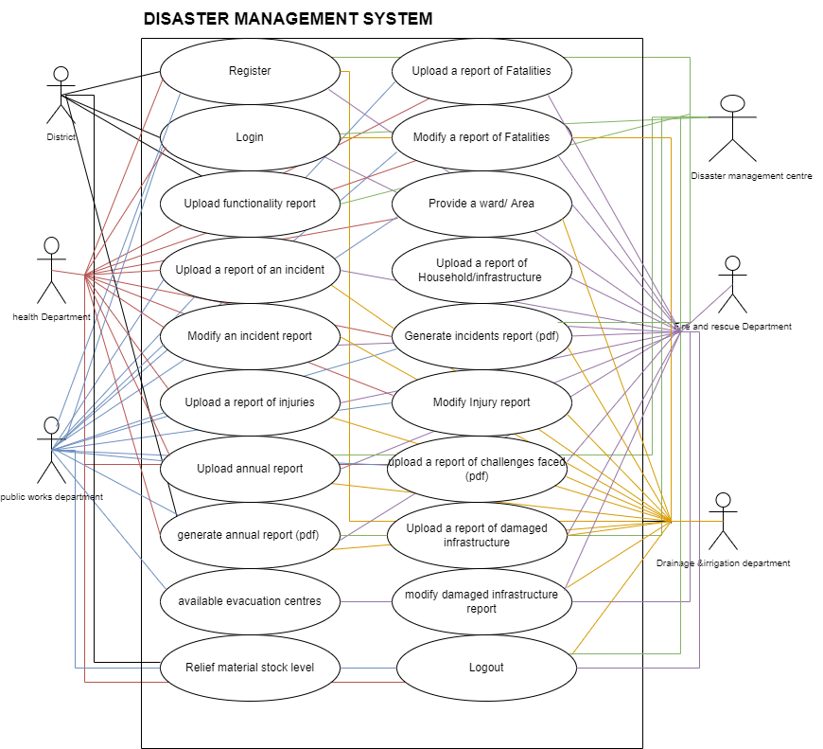

* 1. **The following characteristics/ functionalities would be applicable to the system, namely-**
     1. Web-based System
     2. Be integrated to the COGTA website.
     3. System should be user-friendly.
     4. The principles of system design and development are based on business process.
     5. User- selected data can be exported directly into, for example, Microsoft Excel.
     6. Remote access must be possible.
     7. System must be modularized and allow for additional modules to be added at later stages.
     8. Allow for real time data capturing.
     9. Enable various levels of security.
     10. Real time reporting in various formats.
     11. Integrated Document Management System.
     12. Provide Audit trail.
     13. Reports- System must be able to generate various reports.
     14. Mobile access
     15. Administration- maintains access to the system, generation of new reports, resolving bugs in the system.

1. **Technical Functionality**

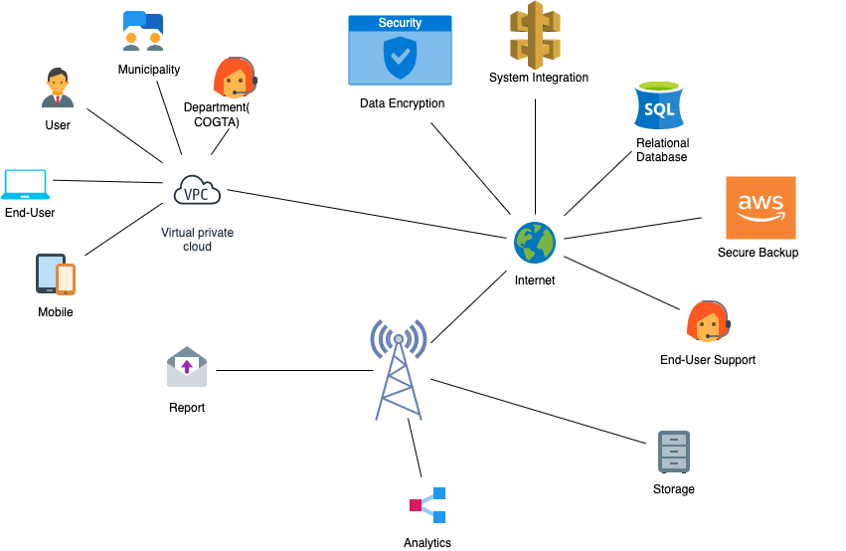

**INTEGRATION PATTERN**

The chosen implementation pattern has been chosen based on affordability, scalability and portability. The core of the COGTA Web System will be developed as a Java Enterprise Applications which will be hosted on a SQL Application Server. Three web-based applications will be implemented for the 3 different channels (Intranet, Mobile Access, and Public Web). The Intranet Web Application will be the main application used by the HUB personnel to access all the features of the Management System. The Mobile Web Application will allow remote access to officials via PDAs and Tablets. The COGTA Departmental Web Access pages will allow the Municipalities to update information that is available from their Municipalities according to the designed system templates for COGTA to get their intended reports.

**5. Proposed System requirements**

Forek Institute of Technology system development team works with an objective to provide all the possible services to get the COGTA Department on the web with easy-to-use facilities and software tools to upgrade the COGTA Department to a new height they by making sure the strategic goal is met.

Forek Institute of Technology is a customer-specific service-oriented company that extends services ranging from preliminary analysis and planning to detailed design, development with seamless integration capabilities for new technology to adapt with existing systems thus ensuring no setbacks in either current or future business strategy.

**5.1. Platforms Supported**

Our Software professionals are proficient in the following technologies and tools:

a) Software Development:

* .NET C#
* JavaScript, jQuery

b) Web Development:

* Ajax
* ASP.NET CORE
* ASP.NET MVC
* XML, HTML5, CSS3
* BOOTSTRAP 5
* Crystal Report, RDLC REPORTS.

c) Multimedia Development:

* Corporate Presentations / Interactive Websites / Product Catalogues / Virtual Walkthroughs Using - Macromedia Flash, Adobe Photoshop, Adobe Premiere & Audition.

d) Database:

* RDBMS (SQL SERVER)
* MS Access, Flat Files, Sybase

e) Application Server:

* Tomcat.
* JRUN
* Weblogic
  1. **Web Server Hardware**
* 8GHz+ processor.
* 16+ GB RAM.
* 1TB free hard drive space (or an appropriate amount for additional file storage)
* Dedicated server or Dedicated Virtual Server Environment
* LCD monitor 17 inches
* Mouse and Keyboard
  1. **Deliverables**

|  |  |
| --- | --- |
| **Deliverable** | **Description** |
| Project Initiation Phase | This is phase where the Contract is awarded and Forek institute sign an SLA with COGTA. |
| Project Planning Phase | Content Planning and Development, necessary research and information gathering. Develop the project plan to guide the rolling out of the system. |
| As-Is Analysis Phase | On this phase we define the current systems in place that are been used by COGTA and identify the gaps in the system. |
| To be Document Phase | Design the main page layout, arrange links and design the database tables. Submitting a proposed document that maps the actual requirements to answer the COGTA system requirements based on the AS IS ANALYSIS. |
| Requirement Analysis Phase | On this phase we Analyze the user needs and develops user requirements.  Create detailed functional requirements document. |
| Designing Phase | In consultation with COGTA IT/CIO Directorate, design and develop the system based on the proposed system requirements and in accordance with the proposal scope of Work.  Transforms detailed requirements in to complete, detailed system specifications. Focuses on how to deliver the required functionality |
| Programming Phase | Converts a design into a complete SYSTEM.  Include acquiring and installing systems environment, creating  and testing databases/ preparing test case procedures; preparing test files; coding; compiling; performing test readiness review and procurement activities. |
| Testing Phase | Demonstrates that the developed system conforms to requirements as specified in the FRD. |
| Deployment and configuration Phase | Includes deployment preparations, deployment of the system into a production environment, resolution of problems identified in the integration and test phase |
| Training and Skills Transfer | Providing Training to system users and to IT Specialist. |
| System maintenance and support | To provide day to day troubleshooting and maintenance. |

1. **Project Implementation plan**

|  |  |  |  |
| --- | --- | --- | --- |
| Deliverable | Description | Responsible | Duration |
| Project Initiation Phase | This is phase where the Contract is awarded and Forek institute sign an SLA with COGTA. | * Forek Project manager * COGTA IT Representative * Project Coordinator | 7 days |
| Project Planning Phase | Content Planning and Development, necessary research and information gathering. Develop the project plan to guide the rolling out of the system. | * Project manager * COGTA IT Representative * Project Coordinator * Programmer X2 * Systems Analyst & Design X 2 * Business Analyst * Graphic Designer | 15 days |
| As-Is Analysis Phase | On this phase we define the current systems in place that are been used by COGTA and identify the gaps in the system. | * COGTA Project Manager * FOREK Project Manager * Project Coordinator * COGTA IT Representative * Programmer X2 * Systems Analyst & Design X2 * Business Analyst * Graphic Designer | 44 days |
| To be Document Phase | Design the main page layout, arrange links and design the database tables. Submitting a proposed document that maps the actual requirements to answer the COGTA system requirements based on the AS IS ANALYSIS. | * COGTA Project Manager * FOREK Project Manager * Project Coordinator * COGTA IT Representative * Programmer X2 * Systems Analyst & Design X2 * Business Analyst * Graphic Designer | 22 days |
| Requirement Analysis Phase | On this phase an Analyses the user needs and develops user requirements is done.  Create detailed functional requirements document. | * COGTA Project Manager * FOREK Project Manager * Project Coordinator * COGTA IT Representative * Programmer X2 * Systems Analyst & Design X2 * Business Analyst * Graphic Designer | 22 days |
| Designing Phase | In consultation with COGTA IT/CIO Directorate, design and develop the system based on the proposed system requirements and in accordance with the proposal scope of Work.  Transforms detailed requirements in to complete, detailed system specifications. Focuses on how to deliver the required functionality | * -Project Manager * Project Coordinator * COGTA Project manager * Systems Analyst & Design X2 * Business Analyst | 22 days |
| Programming Phase | Converts a design into a complete SYSTEM.  Include acquiring and installing systems environment, creating  and testing databases/ preparing test case procedures; preparing test files; coding; compiling; performing test readiness review and procurement activities. | * Project Manager * Project Coordinator * Programmer x 2 | 66 days |
| Testing Phase | Demonstrates that the developed system conforms to requirements as specified in the FRD. | * Systems Tester * Project Manager * Project Coordinator * COGTA Project manager * Programmer X 2 * System users * Network Analyst & Technical Support X 2 | 22 days |
| Deployment and configuration Phase | Includes deployment preparations, deployment of the system into a production environment, resolution of problems identified in the integration and test phase | * Systems Tester * Project Manager * Programmer X 2 * Project Coordinator * COGTA Project manager * System users * Network Analyst & Technical Support | 5 days |
| Training and Skills Transfer | Providing Training to system users and to IT Specialist. | * Business Analyst * COGTA Project Manager * System Users | 10 days |
| System maintenance and support | To provide day to day troubleshooting and maintenance. | * Network Analyst & Technical Support | 24 months |

1. **Resources**.
   1. Key Resources & Qualifications

|  |  |  |  |
| --- | --- | --- | --- |
| PERSONNEL | Qualification | Responsibility | Years of experience |
| Dr Sihle Sibiya | PhD | Project Manager/Testing | 15 |
| Ekson Sibiya | BSc (Computer Science) | Project Coordinator | 13 |
| Lungile Luthuli | Adv Dip (IT) | Business Analyst | 7 |
| Collen Mawela | BTech (IT) | Programmer | 15 |
| Thokozani Ngwenyama | BSc (Hons) IT | Network Analyst and Technical Support | 15 |
| Godfrey Shongwe | Dip (IT) | Programmer | 15 |

1. **Pricing Schedule**
   1. **Summarised Resources Rates for the whole Project and Cost**

|  |  |  |  |
| --- | --- | --- | --- |
| PERSONNEL | Number of days | Rate per hour | Hours per day |
| Dr Sihle Sibiya | 225 | R 1,200.00 | 8 |
| Ekson Sibiya | 225 | R 1,021.00 | 8 |
| Lungile Luthuli | 135 | R 950.00 | 8 |
| Leon Mashele | 125 | R 912.00 | 8 |
| Collen Mawela | 196 | R 950.00 | 8 |
| Godfrey Shongwe | 196 | R 950.00 | 8 |
| Thokozani Ngwenyama | 555 | R650 | 8 |
| Ayanda Sikhosana | 555 | R650 | 8 |

* 1. **Cost Analysis**

|  |  |  |
| --- | --- | --- |
| **ITEM** | **DESCRIPTION** | **AMOUNT** |
| PHASES | Project Initiation Phase | **R 124,376.00** |
| Project Planning Phase | **R 827,400.00** |
| As-Is Analysis Phase | **R 2,427,040.00** |
| To be Document Phase | **R 1,213,520.00** |
| Requirement Analysis Phase | **R 1,050,160.00** |
| Designing Phase | **R 879,120.00** |
| Programming Phase | **R 2,175,888.00** |
| Testing Phase | **R 954,096.00** |
| Deployment and configuration Phase | **R 216,840.00** |
| Training and Skills Transfer | **R 76,000.00** |
| System maintenance and support | **R 5,491,200.00** |
| **TOTAL** | | **R 15,453,640.00** |
| **VAT** | | **R 2,315,346.00** |
| **GRAND TOTAL** | | **R 17,750,986.00** |

* 1. **Monthly Service Level Agreement (Cost Per Month)**
     1. The monthly SLA will be R 228,800.00 Deduced from the Maintenance and support amount